**NAME : MANSI BEURA**

**REGISTER NO : 192210488**

**SLOT : B**

**SUBJECT CODE : CSA1581**

**SUBJECT NAME : CLOUD COMPUTING AND BIG**

**DATA ANALYTICS FOR**

**NETWORK VISUALIZATION**

**EXERCISE 1**

Create a simple cloud software application and provide it as a service using any Cloud Service Provider to demonstrate Software as a Service (SaaS)

**DATE : 24-06 - 2024**

**AIM:** To create and deploy a simple cloud software application as a service using a cloud service provider to demonstrate Software as a Service (SaaS).

**OUTPUT STEPS AND IMPLEMENTAION**

**STEP 1**

Opening Zogo .com

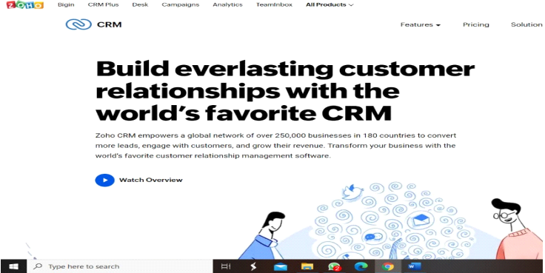

**STEP 2**

Login to the zogo.com

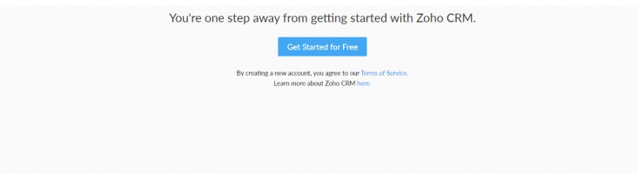

**STEP 3**

Selected one application

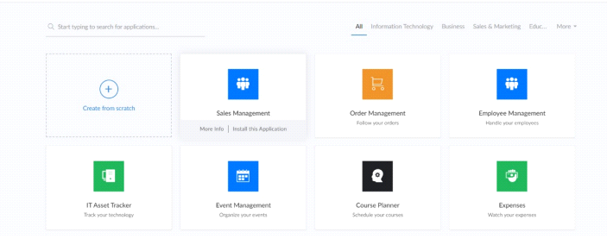

**STEP 4**

Entered the application name

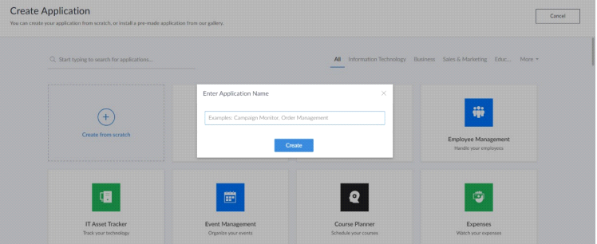

**STEP 5**

Crated new application

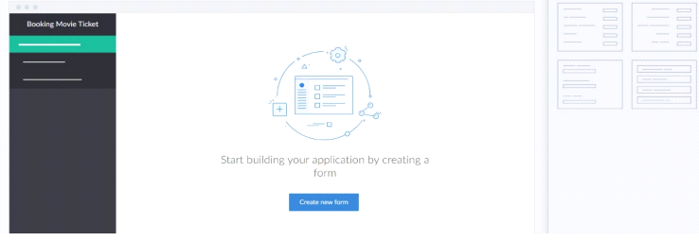

**STEP 6**

Select one form

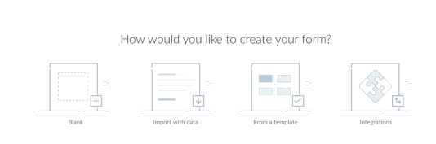

**STEP 7**

The software has been created

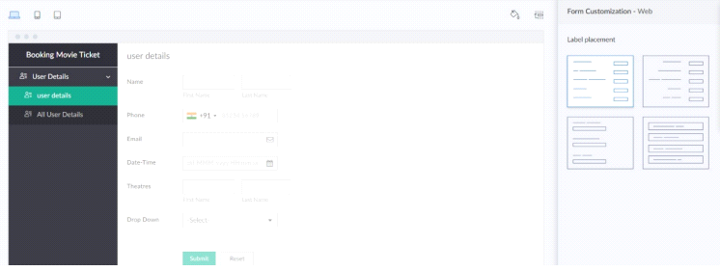

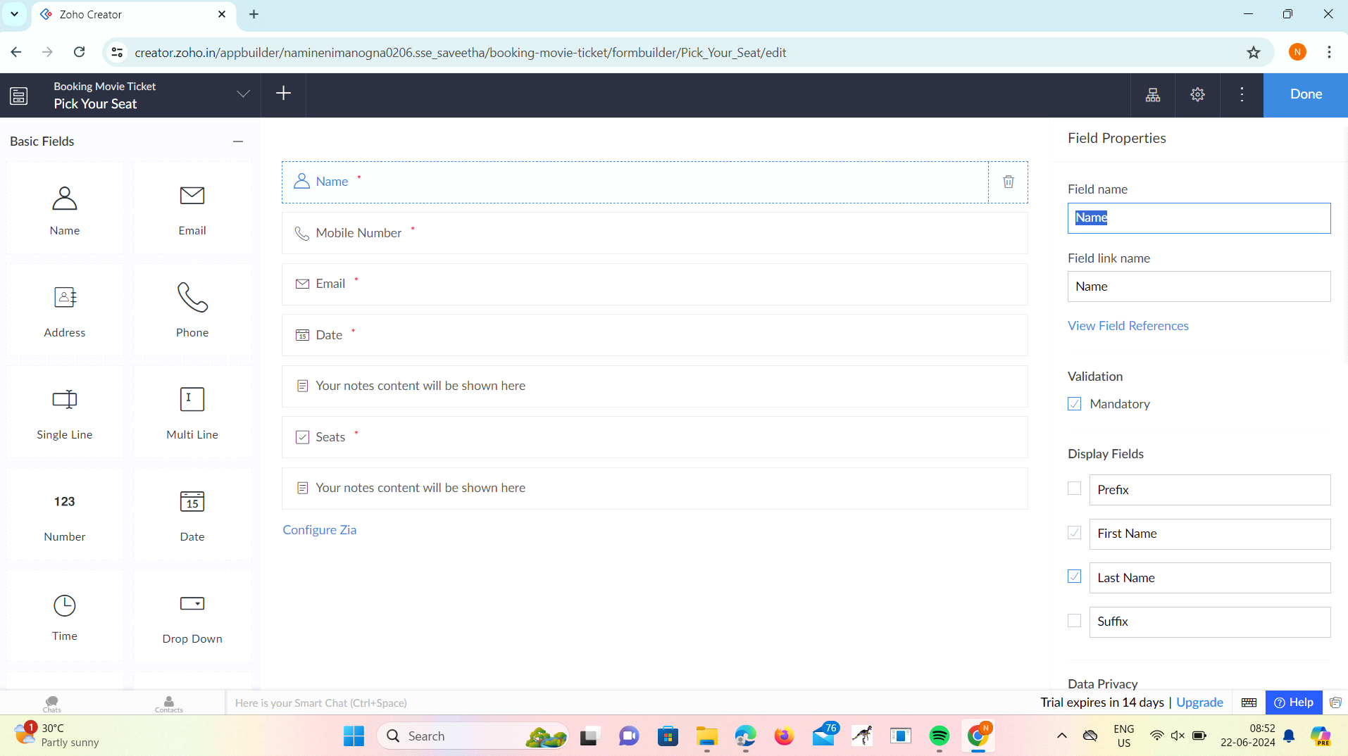

**EXERCISE 2**

**CREATE A SIMPLE CLOUD SOFTWARE APPLICATION FOR FLIGHT RESERVATION SYSTEM USING ANY CLOUD SERVICE PROVIDER TO DEMONSTRATE SAAS.**

**DATE: 24-06-2024**

**AIM:**

**To create a simple cloud software application for flight reservation system using any cloud service provider to demonstrate saas.**

**OUTPUT STEPS AND IMPLEMENTAION**

**STEP 1**

Opening Zogo .com



**STEP 2**

Login to the zogo.com



**STEP 3**

Selected one application



**STEP 4**

Entered the application name



**STEP 5**

Crated new application



**STEP 6**

Select one form



**STEP 7**

The software has been created





**EXERCISE 3**

**CREATE A SIMPLE CLOUD SOFTWARE APPLICATION FOR PROPERTY BUYING & RENTAL PROCESS (IN CHENNAI CITY) USING ANY CLOUD SERVICE PROVIDER TO DEMONSTRATE SAAS.**

**DATE:24-06-2024**

**AIM:**

**To Create a simple cloud software application for Property Buying & Rental process (In Chennai city) using any Cloud Service Provider to demonstrate SaaS.**

**OUTPUT STEPS AND IMPLEMENTAION**

**STEP 1**

Opening Zogo .com



**STEP 2**

Login to the zogo.com



**STEP 3**

Selected one application



**STEP 4**

Entered the application name



**STEP 5**

Crated new application



**STEP 6**

Select one form



**STEP 7**

The software has been created





**EXERCISE 4**

**CREATE A SIMPLE CLOUD SOFTWARE APPLICATION FOR CAR BOOKING RESERVATION SYSTEM USING ANY CLOUD SERVICE PROVIDER TO DEMONSTRATE SAAS.**

**DATE:**

**AIM:**

**To Create a simple cloud software application for Car Booking Reservation System using any Cloud Service Provider to demonstrate SaaS.**

**OUTPUT STEPS AND IMPLEMENTAION**

**STEP 1**

Opening Zogo .com



**STEP 2**

Login to the zogo.com



**STEP 3**

Selected one application



**STEP 4**

Entered the application name



**STEP 5**

Crated new application



**STEP 6**

Select one form



**STEP 7**

The software has been created





**EXERCISE 5**

**CREATE A SIMPLE CLOUD SOFTWARE APPLICATION FOR LIBRARY BOOK RESERVATION SYSTEM FOR SIMATS LIBRARY USING ANY CLOUD SERVICE PROVIDER TO DEMONSTRATE SAAS**

**DATE:24-06-2024**

**AIM:**

**To Create a simple cloud software application for Library book reservation system for SIMATS library using any Cloud Service Provider to demonstrate SaaS**

**OUTPUT STEPS AND IMPLEMENTAION**

**STEP 1**

Opening Zogo .com



**STEP 2**

Login to the zogo.com



**STEP 3**

Selected one application



**STEP 4**

Entered the application name



**STEP 5**

Crated new application



**STEP 6**

Select one form



**STEP 7**

The software has been created





**EXERCISE 6**

**CREATE A SIMPLE CLOUD SOFTWARE APPLICATION FOR PRODUCT SELLING USING ANY CLOUD SERVICE PROVIDER TO DEMONSTRATE SAAS.**

**DATE:25-06-2024**

**AIM:**

**To create a simple cloud software application for product selling using any cloud service provider to demonstrate saas.**

**OUTPUT STEPS AND IMPLEMENTAION**

**STEP 1**

Opening Zogo .com



**STEP 2**

Login to the zogo.com



**STEP 3**

Selected one application



**STEP 4**

Entered the application name



**STEP 5**

Crated new application



**STEP 6**

Select one form



**STEP 7**

The software has been created





**EXERCISE 7**

**DEMONSTRATE VIRTUALIZATION BY INSTALLING TYPE-2 HYPERVISOR IN YOUR DEVICE, CREATE AND CONFIGURE VM IMAGE WITH A HOST OPERATING SYSTEM (EITHER WINDOWS/LINUX).**

**DATE:25-06-2024**

**AIM:**

**To demonstrate virtualization by installing type-2 hypervisor in your device, create and configure VM image with a host operating system (either windows/linux).**

**OUTPUT STEPS AND IMPLEMENTAION**

**STEP 1**

DOWLOADED VMWARE WORKSTATION AND INSTALLED AS TYPE 2 HYPERVISOR

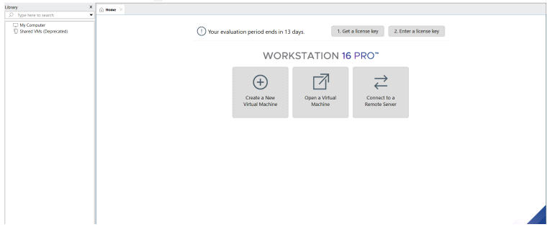

**STEP 2**

DOWLOADED UBUNTU

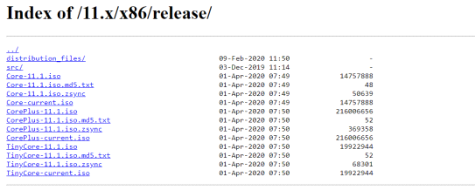

**STEP 3**

Created new VM ware workstation

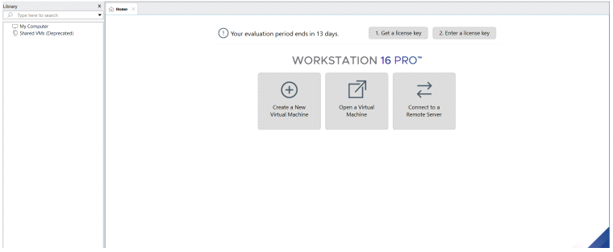

**STEP 4**

**Basic configuration settings were done**

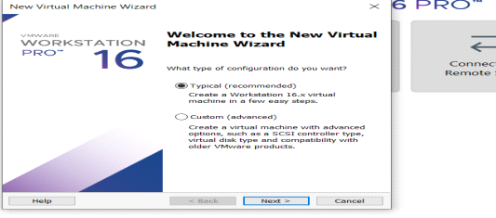

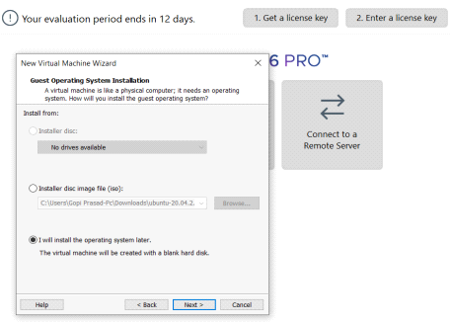

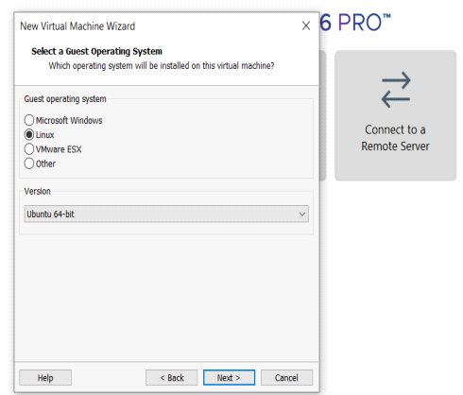

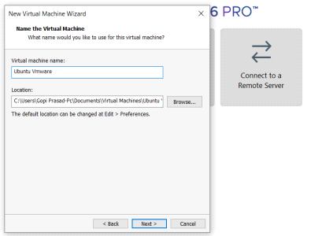

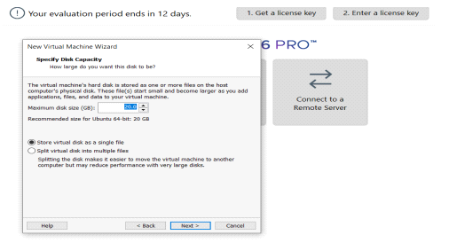

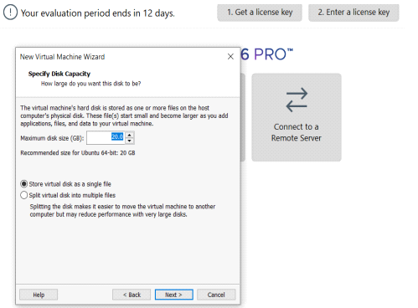

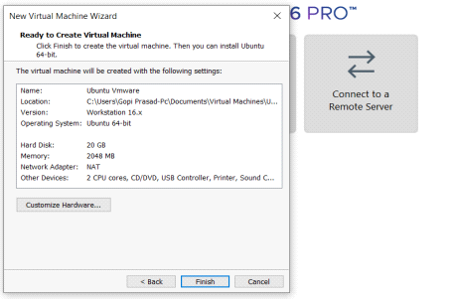

**STEP 5**

Created OS Vertual machine

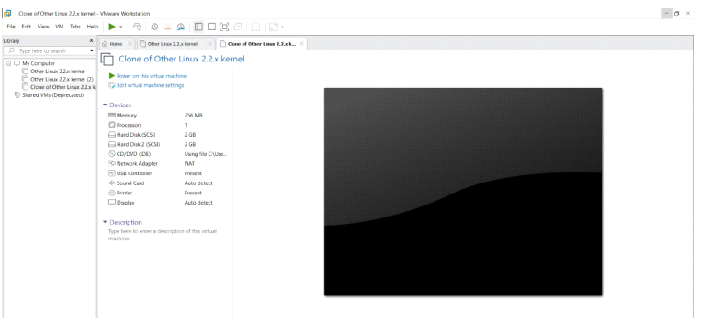

**STEP 6**

Lunched the VM

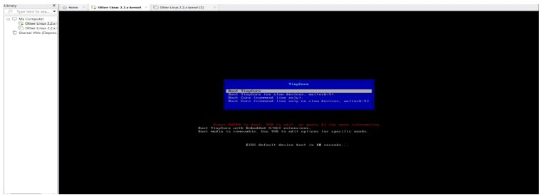

**EXERCISE 8**

Create a Virtual Machine with 1 vCPU, 2GB RAM and 15GB storage disk using a Type 2 Virtualization Software

**DATE : 25-06-2024**

**AIM:** To create a virtual machine with specific hardware specifications using Type 2 Virtualization software

**OUTPUT STEPS AND IMPLEMENTAION**

**STEP 1**

DOWLOADED VMWARE WORKSTATION AND INSTALLED AS TYPE 2 HYPERVISOR



**STEP 2**

DOWLOADED UBUNTU



**STEP 3**

Created new VM ware workstation



**STEP 4**

**Basic configuration settings were done**















**STEP 5**

Created OS Vertual machine



**STEP 6**

Lunched the VM



**EXERCISE 9**

CREATE A VIRTUAL HARD DISK AND ALLOCATE THE STORAGE USING VM WARE WORKSTATION

**DATE :25-06-2024**

**AIM:** To create a Virtual Hard Disk and allocate storage using VMWare Workstation.

**OUTPUT STEPS AND IMPLEMENTAION**

**STEP 1**

DOWLOADED VMWARE WORKSTATION AND INSTALLED AS TYPE 2 HYPERVISOR



**STEP 2**

DOWLOADED UBUNTU



**STEP 3**

Created new VM ware workstation



**STEP 4**

**Basic configuration settings were done**















**STEP 5**

Created OS Vertual machine



**STEP 6**

Lunched the VM



**EXERCISE 10**

**CREATE A SNAPSHOT OF A VM AND TEST IT BY LOADING THE PREVIOUS VERSION/CLONED VM**

**DATE:25-06-2024**

**AIM:**

**To create a snapshot of a vm and test it by loading the previous version/cloned vm**

**OUTPUT STEPS AND IMPLEMENTAION**

**STEP 1**

DOWLOADED VMWARE WORKSTATION AND INSTALLED AS TYPE 2 HYPERVISOR



**STEP 2**

DOWLOADED UBUNTU



**STEP 3**

Created new VM ware workstation



**STEP 4**

**Basic configuration settings were done**















**STEP 5**

Created OS Vertual machine



**STEP 6**

Lunched the VM



**EXERCISE 11**

**CREATE A CLONING OF A VM AND TEST IT BY LOADING THE PREVIOUS VERSION/CLONED VM.**

**DATE:**

**AIM:**

**To create a cloning of a vm and test it by loading the previous version/cloned vm.**

**OUTPUT STEPS AND IMPLEMENTAION**

**STEP 1**

DOWLOADED VMWARE WORKSTATION AND INSTALLED AS TYPE 2 HYPERVISOR



**STEP 2**

DOWLOADED UBUNTU



**STEP 3**

Created new VM ware workstation



**STEP 4**

**Basic configuration settings were done**















**STEP 5**

Created OS Vertual machine



**STEP 6**

Lunched the VM



**EXERCISE 12**

**CHANGE HARDWARE COMPATIBILITY OF A VM (EITHER BY CLONE/CREATE NEW ONE) WHICH IS ALREADY CREATED AND CONFIGURED.**

**DATE:26-06-2024**

**AIM:**

**To Change Hardware compatibility of a VM (Either by clone/create new one) which is already created and configured.**

**OUTPUT STEPS AND IMPLEMENTAION**

**STEP 1**

DOWLOADED VMWARE WORKSTATION AND INSTALLED AS TYPE 2 HYPERVISOR



**STEP 2**

DOWLOADED UBUNTU



**STEP 3**

Created new VM ware workstation



**STEP 4**

**Basic configuration settings were done**















**STEP 5**

Created OS Vertual machine



**STEP 6**

Lunched the VM

